Empirical Exercise #2

Group 19: India, Group Members: Taras Vorobets, Shail Shah, Parv Joshi

**Results for the United States**

**Table 1: United States: 1960-2017 (Entire Time Period)**

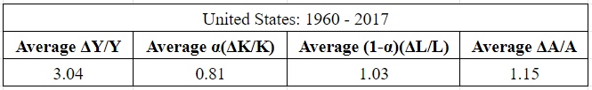

**Interpretation**: These are the total averages stemming from the years 1960-2017 (The entire time period for which we have data). They represent the average annual ratios of(ΔY/Y), α(ΔK/K), (α-1)(ΔL/L), and (ΔA/A). The total output of the United States should be the cumulative sum between the three averages. These years include the developing economic statistics which occurred through the Early 80’s Recession, Black Monday, the 2001 dot com bubble, and the most recent 2008 financial crisis. They represent that the overall average of the labor compared to capital was higher through these years when you account for all the economic growths and crashes. The average output reflects that the technological growth through the history of the United States starting from 1960 to 2017 is relatively the same as the average of labor output. Together these figures make up the different sources of growth for the United States economy through 1960-2017.

**Table 2: United States: 1995-2006 (Sub Period 1)**

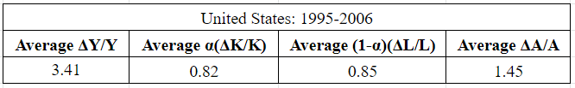

**Interpretation:** These are the total averages stemming from the years 1995-2007 (We chose 1995 because that's when the IT revolution started showing an increase in productivity. We chose 2006 to see the results before the Financial Crisis in 2007). They represent the average annual ratios of (ΔY/Y), α(ΔK/K), (α-1)(ΔL/L), and (ΔA/A). Taking place right after the end of the cold war between communist and socialism as well as going through the dot com bubble, this time frame reflects various economic developments in the United States’ economic history. As various technological advancements took place during this time the statistics reflect a similar interpretation, i.e. a higher value of average ΔA/A (compared to the entire timeline). During this time the capital and labor output remained relatively constant and equal to each other. However, the output growth was visible through the contribution of technological growth, which was higher than capital or labor outputs.

**Table 3: United States: 2007-2017 (Sub Period 2)**

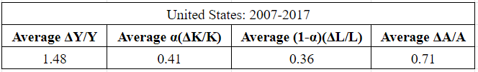

**Interpretation:** These are the total averages stemming from the years 2008-2017 They represent the annual ratios between (ΔY/Y), α(ΔK/K), (α-1)(ΔL/L), and (ΔA/A). During this time in the United States history as well as the world, the financial crisis occurred as the mortgages crashed in the housing market, affecting economies all around the world. This outlier drastically changed the statistics of the average output of capital and labor during 2007-2017 as seen above. This crisis caused the government to pour money into the economy due to high unemployment rates as well as people's reluctance to work with banks which essentially closed down due to unsustainable financial policy. These historical moments are reflected in the statistics of the average output of the United States during this time, significantly lower than the years 1995-2007. Despite the capital and labor output averages remained relatively equal in the percentage of total output, the average technological growth decreased as well. This shock was felt all around the world and can be seen in the statistics of India as well, during the same time period.

**Results for India**

**Table 4: India: 1960-2017 (Entire Time Period)**

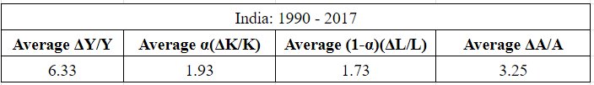

**Interpretation:** These are the total averages stemming from the years 1990-2017 They represent the average annual ratios of (ΔY/Y), α(ΔK/K), (α-1)(ΔL/L), and (ΔA/A). Working with limited data for India, the data is curved toward more recent growth of the economy, showing a large output. During this time period, many economic developments took place. India's economy started growing exponentially increasing after staggering technological growth occurring at the start of the 20th century. Trying to optimize labor, the nation's development of capital was a large portion of its total output. We also see that the GDP share of capital is more than the share of Labor despite its enormous population. From the data, it is clear that this could be because of its increase in the unemployment rate which peaked in 1993, 2002 and 2009. However, the major impact of the high average output India has managed to produce during these years came from large leaps in technological advancement, which from 1990 to 2017 consisted of almost half of total output.

**Table 5: India: 1995-2006 (Sub Period 1)**

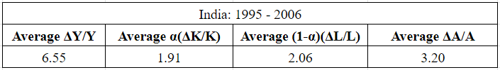

**Interpretation:** These are the total averages stemming from the years 2008-2017 They represent the annual ratios between (ΔY/Y), α(ΔK/K),α-1(ΔL/L), and (ΔA/A). Being the world's third-largest economy, India has experienced its fair share of hardship and success. Turning a new leaf in 1991, when it embarked on a liberal reform, India faced massive social class disbalance as a majority of its population was lower class. The unemployment rate peaked in 2002 that reduced the share of Labor (similar to the share of capital) Moving past the 2000’s India's reform was proven highly successful despite the Asian financial crisis of 1997-1999, dotcom collapse, 2001 global recession and the natural disaster phenomenon such as droughts and food shortages. Despite only having statistical data from 1990, the numbers still reflect these economic growths and slowdowns in the average capital and labor outputs. Despite this, by 2006 India was still able to achieve a large total output which was half in part to the staggering technological growth in this time period.

**Table 6: India: 2007-2017 (Sub Period 2)**

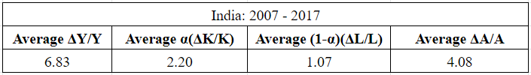

**Interpretation:** These are the total averages stemming from the years 2008-2017 They represent the average annual ratios of (ΔY/Y), α(ΔK/K), (α-1)(ΔL/L), and (ΔA/A). Right before the 2008 financial crisis which affected the whole world, India’s economic growth continued to increase due to the global boom spearheaded by China, which lifted India’s GDP due to trade, reflected in terms of total output and technological growth. However, the labor output took a low as India encountered massive layoffs and problems arose from 2010 to 2011 with widespread corruption resulting in financial losses, and infrastructure losses which were essential to the whole population. Despite this, India's economy continued to grow in all other aspects during this time period. Once again technological growth prevailed at an astounding rate-making up for a total of more than 50% of total outputs. The average capital growth increased as well from the previous time period, reassuring the success of a reformed India.

**Comparison**

Looking over all the data we’ve acquired for both India and the United States we made numerous comparisons between the two. Despite the countries experiencing relatively similar economic crashes during the same periods, the statistics remained relatively similar from different sub-periods for each country. The United States experiences relatively similar capital and labor outputs. India experienced increased growth after the reform of 1991 which converted the government to be more focused on economic growth and trade. In both countries, the share of capital and labor was almost the same as total output. However, in the U.S the share of labor was slightly higher than the capital while in India the share of capital was slightly higher than the labor. Technological growth was quite a surprising statistic for both countries as it made up about half of the total output for both India and the United States, demonstrating its importance in Economic Development. Growth rates in India were much higher due to its rapidly expanding economy which was also visible through the higher outputs during the time periods. Overall, despite the data constraints for India, both countries showed remarkable economic growth consisting of different economic factors and shocks (positive or negative), which as a group we found very interesting to observe and analyze.